Lesson 6

Polynomial Functions

SPECIFIC OBJECTIVES:

At the end of the lesson, the student is expected to be able to:

- Identify a polynomial function.
- Distinguish a polynomial function from among different types of functions.
- Determine the degree of a polynomial function.
- Determine the value of the function with the use of the Remainder Theorem.
- Use the Factor Theorem to determine the factors of a polynomial.
- Use Descartes’ Rule of Signs to determine the maximum number of positive and negative roots of a polynomial equation.
- Locate all possible rational roots/zeroes of a polynomial equation.
- Approximate the graph of a polynomial function.

6.1 Polynomial Function

Definition 6.1.1 Polynomial Function

A function f(x) is a polynomial function of degree n if f(x) is of the form
f(x) =
where all the coefficients 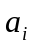 for i = 0,1,…,n are real numbers (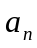≠0) and n is a non-negative integer.

Example 6.1.1 Determine the degree of each of the following polynomial functions:

a) 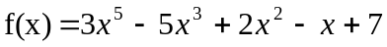 ans. 5th degree
b) ans. 7th degree
c) 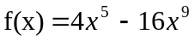 ans. 9th degree

Exercise 6.1.1 Determine the degree of each of the polynomial functions.
a. 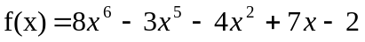
b. 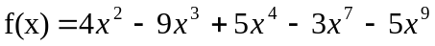
c. 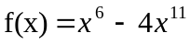
d. 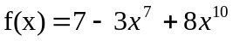

Definition 6.1.2 The Remainder Theorem

If a polynomial f(x) is divided by a linear factor (x-r), the remainder is the value of the function at x=r. That is ,

if f(x) = Q(x-r) + R , then f(r) = R.

Example 6.1.2 Use the Remainder Theorem to determine the desired functional value at the given x for each of the following polynomial functions at the given x:

a) 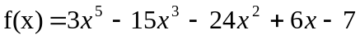 at x= 3 ans. 119
b) at x = -2 ans. -5
c) 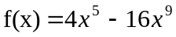 at x = ½ ans. 3/32
d) ans. 1

Exercise 6.1.2 Use the Remainder Theorem to determine the desired functional value at the given x for each of the following polynomial functions.

a) 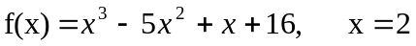
b) 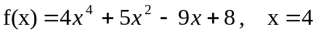
c) 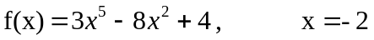
d) 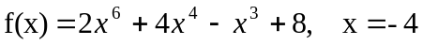

Definition 6.1.3 Synthetic Division

Synthetic division is a short, simple method of performing division of a polynomial f(x) = by a binomial (x-r).

Steps to be followed in synthetic division:

- Arrange the terms of the polynomial in the decreasing powers of the variable.

- Write the coefficients of the terms in the first row including missing terms with zero as coefficients. To the left of the first row, write the number r from x-r.

r ⎦

- Bring down the first coefficient to the third row. Multiply this by r and place the product in the second row under the second coefficient of the first row. Obtain the sum of this product and the second coefficient and place the result in the third row. Repeat this multiply-and-add procedure for all the succeeding terms until the last term of the first row.

r ⎦
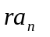 . . . . . . .
___________________________________

- The last number of the third row is the remainder and the other numbers from
left to right are the coefficient of the terms of the quotient, which is of degree
one less than the given polynomial.

Remark:
If the divisor is in the form of ax+b, rewrite as a(x+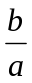) and use (x+) as divisor. The resulting quotient is a times what it should be. Hence, this result should be divided by a except the remainder.

Example 6.1.3 Using synthetic division, divide the first polynomial by the second.

a)
ans. 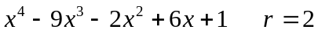

b) 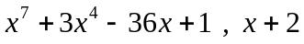
ans.

c) 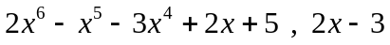
ans. 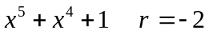

d)

ans. 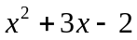

Exercise 6.1.3 Using synthetic division, divide the first polynomial by the second.

a) 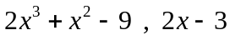
b)
c)

Definition 6.1.4 The Factor Theorem

The linear binomial (x-r) is a factor of the polynomial f(x)= , if and only if, f(r) = 0.

Example 6.1.4 Use the Factor Theorem to verify whether the indicated linear
binomial is a factor of the given polynomial function. Use
synthetic division as desired.

a) , x – 2 ans. Not factor
b) 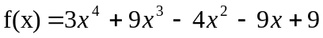 , x+ 3 ans. factor
c) , x - ½ ans. Not factor
d) ans. factor
e) ans. factor

Exercise 6.1.4 Use the Factor Theorem to verify whether the indicated linear binomial is a factor of the given polynomial function. Use synthetic division as desired.

a) 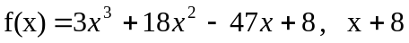
b) 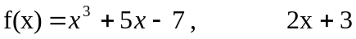
c)
d)

Example 6.1.5 Determine the value of k so that (x-r) would be a factor of the
given polynomial.

a) 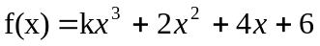, x +1 ans. 4
b) 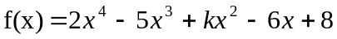 , x-2 ans. 3
c) ans. 1/16

Exercise 6.1.5 Determine the value of k so that (x-r) would be a factor of the given polynomial.

a) 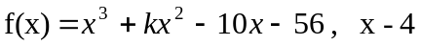
b) 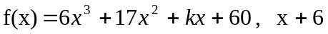
c)

Definition 6.1.5 The Roots/Zeroes of polynomials

If f(r) = 0 , then r is a zero/root/ solution of the polynomial equation
f (x)== 0.
That is,
f(x) = (x-r) Q(x).

Remarks:

- The Fundamental Theorem of Algebra states that every polynomial
equation has at least one root, which may be a real or a complex
number.
- If f(x) is of degree n, then there will be n linear factors.
- Every polynomial equation of degree n has exactly n roots.
- Complex roots always occur in conjugate pairs, a+bi and a-bi.
- If the coefficients of the equation
F(x)== 0 are integers, then
any rational roots are factors of 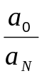.
- Descartes’ Rule of Signs states that the number of positive real roots
of f(x) = 0 is equal to the number of variation in sign of f(x) or less than
this by an even integer. While the number of negative real roots is
equal to the number of variation in sign of f(-x) or less than this by an
even integer.

- The Theorem on Bounds states that if f(x) is divided by x-r and the
terms of the quotient are either all positive or all negative then r is an
upper bound of the roots. However, if f(x) is divided by x-r and the
terms of the quotient alternate in signs then r is a lower bound of the
roots.

Example 6.1.6 Verify whether the given x-value is a zero of the function.

a) 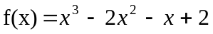, x = -1 ans. A zero
b) 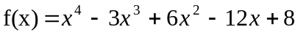 , x= 2 ans. A zero
c) ans. Not a zero

Exercise 6.1.6 Verify whether the given x-value is a zero of the function.

a. 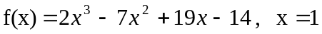
b. 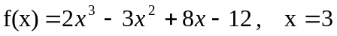
c.

Example 6.1.7 Use Descartes’ Rule of Signs to determine the number of
positive/negative real roots of the given polynomial equation.

a) 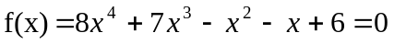 ans. 2 / 2
b) ans. 1 / 3
c) 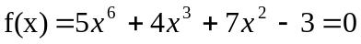 ans. 1 / 3
d) 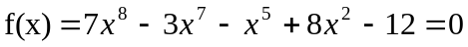 ans. 5/ 1

Exercise 6.1.7 Use Descartes’ Rule of Signs to determine the number of positive/negative real roots of the given polynomial equation.

a)
b)
c)

Example 6.1.8 Determine the upper/ lower bound of the roots for each of the
following equations.

a) 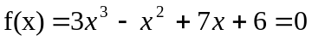
b) 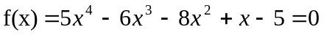
c) 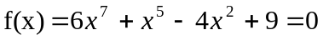
d) 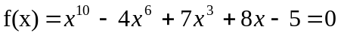

Exercise 6.1.8 Determine the upper and lower bounds of the roots for each of the following equations.
a) 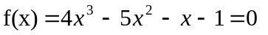
b) 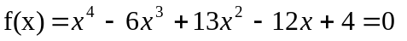
c) 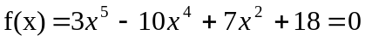

Example 6.1.9 Find all possible rational roots, and then find all roots of the
equation.

a) 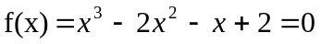 ans. –1, 1, 2
b) 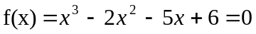 ans. –2, 1, 3
c) 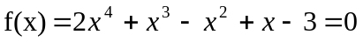 ans. 1, -3/2 , 2i, -2i
d) 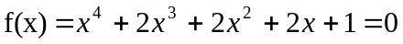 ans. –1, -1, i, -i
e) ans. 1, 5, -1, 1±i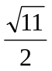
f) ans. 1, 3, 4, -2, ±i

Exercise 6.1.9 Find all possible rational roots, and then find all roots of the
equation.

a) 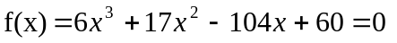
b) 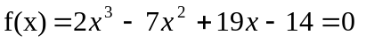
c)
d)
e)

Example 6.1.10 Find a polynomial equation of least possible degree with
rational coefficients whose roots are as follows:

- 1, -1, 3 ans. 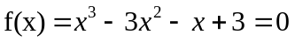
- –1/3, 2, ½,-2 ans. 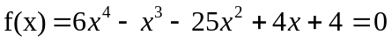
- 2, 5, -3 (multiplicity 2) ans. 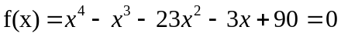
- 2, 1 -  ans. 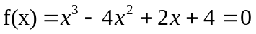
- –1, 2, 3±2i ans.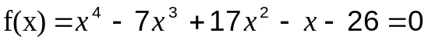

Exercise 6.1.10 Find a polynomial equation of least possible degree with rational coefficients whose roots are as follows:

- 3/2, -2, 5
- –5, -2, 5/6, 3/2, 1
- 2, 3, -4, -3/4 (multiplicity 4)
- 2i, 2+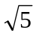 , -3 (multiplicity 2)

Example 6.1.11 Find a polynomial function of smallest possible degree which
satisfies the given conditions:

- f(1) = f(3) = f(6) = 0, f(4) = -12 ans. 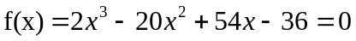
- f(-3), f(1) = f(3) = f(4) = 0 , f(0) = 36
ans 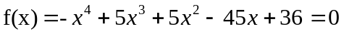
- f(-) = f(= f(1) = 0 , f(-1) = -24
ans 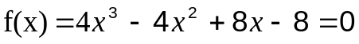
- f(2+3i) = f(2-3i) = f(3+2i) = f(3-2i) = 0, f(1) = 160 ans

Exercise 6.1.11 Find a polynomial function of smallest possible degree which
satisfies the given conditions:

- f(-2) = f(0) = f(3) =0, f(1) =-18
- f(-1) = f(3) = f(-3) = 0 , f(2) = -30
- f(2) = f(3) = f(-1) = f(-2) = 0 , f(1) = 4

6.2 Graphs of Polynomial Functions

Definition 6.2.1 Graphs of Polynomial Functions

The graph of a polynomial function f(x)=
consists of all ordered pairs (x , f(x)) that satisfy the functional rule.

Steps to be followed in sketching the graph of the function:

- The domain of the function is (-∞, ∞). The function is continuous for all values in its domain.
- Determine the range of the function. If n is even and > 0 , the range is the interval [m,∞), where m is the minimum value of the function. If n is even and < 0 , the range is the interval (-∞, m], where m is the maximum value of the function. If n is odd, the range is (-∞, ∞).
- Determine the factors of the polynomial with the aid of the Factor Theorem.
- Find the zeroes of the function (x-intercepts) with the aid of the Remainder Theorem. There will be at most n real zeroes and at most n-1 turning points.
- Identify intervals of x-values as determined by the regions left or right of the zeroes of the function.
- Test the sign of f(x) in each of these intervals by using any value of x in the interval. The graph in that whole interval is above the x-axis if the sign of f(x) is positive while the graph will be below the x-axis if sign of f(x) is negative.

Example 6.2.1 Sketch the graph of each of the given polynomial functions.
a) f(x) = 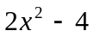
b) f(x) =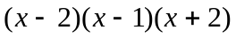
c) f(x) = 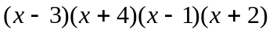
d) f(x) =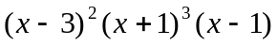
e) f(x) =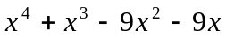

Exercise 6.2.1 Sketch the graph of each of the given polynomial functions.

a) 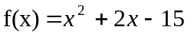
- f(x) = 
 